„User“ view of the Global Features (mostly Push 2)

Legend

Function | hold, touch, press, turn | Knobs/Buttons | Display | Push 1 /2 | Bitwig

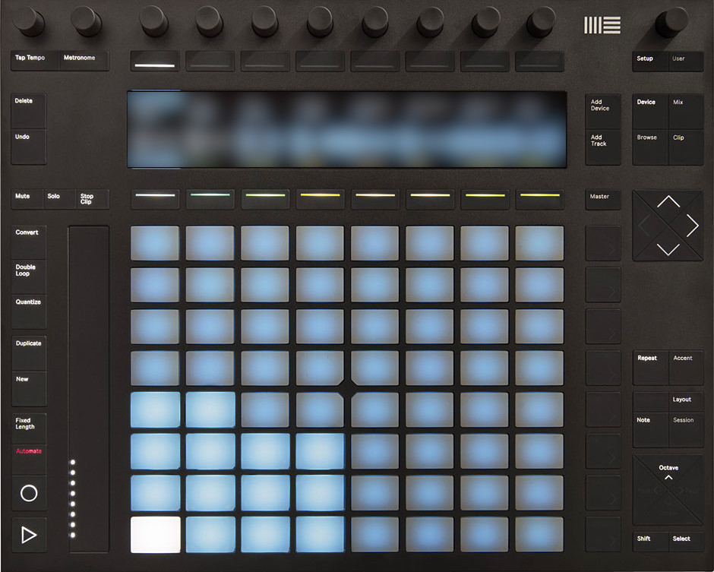
1
2
3
4
5
6
7
8
9
10
11
1
2
3
4
5
6
7
8
9
10
11
Master
upper Display Knobs – upD Knobs
lower Display Knobs – loD Knobs
Pads
Arrow
Octave

Setup
- Push 2 press Setup
- Push 1 press Shift+User
- Adjust Brightness of Display and LEDs (all pads and knobs)
- Adjust Pad Sensitivity with Sensitivity, Gain and Dynamic. Also configurable in the script settings (Settings->Controllers->Ableton Push2->Pads)
- Hardware Information - Pressing Info shows current Firmware Build, the Board Revision and the Serial Number

User (Controls) definierte Parameter
- Push 2 press User
- User Controls opens 8 Pages with 8 free definable parameters each = 64 assignable parameter controls
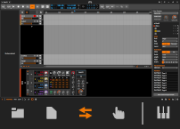
- To rename the page names Page1, Page 2 go to the Bitwig Studio I/O Panel (bottom right) -> Push 2 -> Workflow

Tempo, Metronome & Play Cursor
- Push 2 + Push 1
- Change tempo - turn Knob 1 - for fine adjustment hold Shift + Knob 1
- Set Tempo - tap Tap Tempo with your desired speed.
- Metronome toggle on/off - press Metronome
- Metronome Settings - long press Metronome - press Metronome again to leave settings
- Move play cursor turn Knob 2 - for fine adjustment hold Shift + Knob 2

Play und Record
- Playback start/stop - press Play button
- Move play Cursor to beginning - double click Play You can configure the behavior on stop in the Preferences->Controllers->Ableton Push2->Transport->Behaviour on Stop
- Loop/Repeat on/off - hold Shift + Play
- Punch In on/off - hold Select + Play
- Punch Out on/off - hold Select + Shift + Play
- Start/Stop recording - press Record
- Launcher Overdub on/off - press Shift + Record
- Undo - press Undo
- Redo - press Shift + Undo
- Delete - press Delete Like pressing the delete key. Some more functionality in comibnation with other buttons are explained below
- Automation on/off - press Automation
- Automation Clip Launcher on/off - press Shift + Automation
- Automation Settings - long press & hold Automation for setting Latch, Touch, Write
- Automation Reset - press Delete + Automation

Tracks / Devices
- Add Instrument Track - press Add Track
- Add Audio Track - press Select + Add Track
- Add Effect Track - press Shift + Add Track
- Duplicate Track - press Duplicates + loD Knob that should be duplicated
- Add Device after - Push 2 press Add Device add a device after the current
Push 1 press Add Effect
- Add Device before - Push 2 press Shift + Add Device add a device before the curre
Push 1 press Shift + Add Effect
- Preset Selection - press Browse enters Preset selection mode for a device. If no device is selected the browser is opened to add a device.
- ???? - Shift+Track - Turn off/on VU meters.

Clips in Mix and Clip Launcher
- Stop Clip - press Stop Clip + upD Knob of the clip track to stop
- Stop all Clips - press Shift + Stop Clip
- Solo current Clip - Push 2: press Solo solos the currently selected track
Long press for the Push 1 behavior.
Lock it with press Shift + Solo
Push 1: Selects track solo state of 2nd row.
- Solo Clip of Track - Push 2: press & hold Solo + upD Knob of Track you want to solo
- Lock Solo Function in Display - Push 2: press Shift + Solo ... press Track you want to solo
- Deactivate all solos - press Select + Solo
- Mute current Clip - Push 2: press Mute
Push 1: Selects track mute state of 2nd row.
- Mute Clip - Push 2: press & hold Mute + upD Knob of track .
Push 1: Selects track mute state of 2nd row.
- Lock Mute Function in Display - Push 2: Lock it with press Shift + Solo then Mute
- Deactivate all mutes - press Select + Mute
- New Clip - press New creates a new clip on the selected track and slot, starts play and enables overdub.
- New Clip w/o Overdub - press Shift + New like New Clip but without activating launcher overdub.
- New Clip length - press Fixed Length - Select the length of the midi clip for New
The upper row creates a new clip without storing the option
The lower row stores the option without creating a new clip
- Duplicate Clip - press Duplicates to duplicate the current clip
- Duplicate Clip (Session) - press Duplicates + Pad that should be duplicated
- New Scene from playing Clips - press Shift + Duplicate - Create a new scene from the currently playing clips
- Duplicate Clip Content - press Double Loop
- Quantize Clip - press Quantizes
- Quantize / Groove Settings - press Shift + Quantize or long press Quantize
- Slice to Drum Machine - press Convert Brings up the Slice to Drum Machine dialog.
- Slice to Multi-sample - press Shift + Convert - Bring up the Slice to Multi-sample dialog

Various Knobs and Buttons
- Layouts and Panels - press & hold Master to choose
  - Arrange, Clip Laucher, Timeline, Mix, Edit
  - Notes, Automate, Device, Mixer, Inspector
  - I/O, Markers FX Tracks
  - Follow, Track height, Fullscreen
- Select Play/Sequencer Mode - press Note to open Display Menü for
  - Sequencer - Poly Sequencer - Raindrop - Drum - Drum 4 - Drum 8
  - Play - Piano - Drum 64
  - Tools - Clip - Prg Change
- Layout Mode toggeling - press Layout to toggle through the current selected category:
  - Play: Play, Piano, Drum 64
  - Sequencer: Sequencer, Poly Seq, Raindrop, Drum, Drum 4, Drum 8
- Layout Category switching - press Shift + Layout to switch between Play and Sequener category
- Value change - turn Knobs 1-8 changes values that are displayed
- Value change finetuning - turn Shift + Knob 1-8 changes values in display in smaller steps
- Master Volume - turn Knob 11 / for finetuning hold Shift + turn Knob 11
- Metronome Volume - hold Select + Knob 11
- Switch Track - press Arrow left/right
- Switch Device - press Arrow left/right
- Switch Layer - press Arrow left/right Container Devices like FX Layer, Instrument Layer, Drum Machine
- Switch Scene bank - press Arrow left/right
- Switch Browser Tab - press Arrow left/right. Does only work, when opening the browser with the controller.
- Note Repeat - press Repeat
- Note Repeat Settings - long press Repeat to configure the note repeat settings, press Repeat again to exit
- Pad Velocity Maximum - press Accent so it'‘s illuminated
- Pad Velocity Maximum - press & hold Accent then turn Knob 10 to change the max value
- Scale - press Scale to change the musical mode, the root key, InKey or Chromatic. You have to select an option to exit that screen again
- Touchstrip Pitchbend - touch Touchstrip and move up and down
- Touchstrip Settings - press Shift + Touchstrip send pitch bend, a midi CC or a mixed mode. If mixed mode is selected upwards pitch bend is sent and downwards the select midi cc.
- Footswitch 1 - Sends sustain
- Footswitch 2 - Triggers the new button.

